September 8, 2014Huffpost Arts

Christa Dowling Become a fan
She is passionate about writng and has a deep curiosity about people

The Art of Collecting
Posted: 08/29/2014 5:50 pm EDT Updated: 08/29/2014 5:59 pm EDT
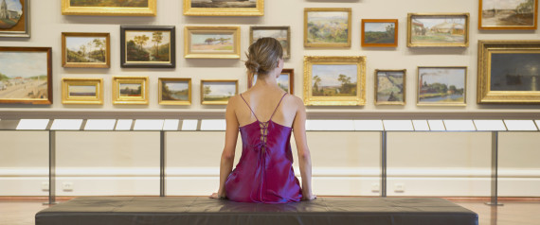
It is a much thought about and much discussed subject for we all collect. We collect friends, information, knowledge, experience and sometimes even dreams. This thought is about "collecting art" and how to go about it, maybe we are searching for inspiration. It often is not about money but of the thought of what we may call passion. It is also about the fear of making the wrong decision and spending a certain amount of money on a whim. Yet finding a passion and pursuing it... is part of it and also the joy. A bit of magic is involved and how one reacts to art. It can be a piece of furniture, a book, a play or music... or above all a person which brings out the best in us. A room with beautifully crafted pieces of furniture, a character in a story makes us want to know him or her. The voice of an actor moves us to be near. Music has a magical influence on our well-being and gives us joy. Looking at a painting or sculpture touches our deep yearning and helps us to dream.
Paintings and sculptures need to be seen and experienced. Learned about... the artist, what is his or her vision, what life has he or she experienced or has lived! Fundamentally one needs to listen to that inner voice and then to how one reacts to the piece one is looking at. How one sees it! How does he or she use color... depth of vision? What are his or her subjects? Is it authentic? Of course there is a lot of fake art, and in time one recognizes it as one does with people.
How does one learn to see authentic art? You can experience and see art in galleries, in museums, in auction houses, listen to lectures, read about art and gather as much information about art and the artist as possible. Developing an 'eye' to see ART takes time and patience. Yet in the end one needs to feel it... how it touches you, how it moves you... and can you live with it and enjoy it. For many centuries art has played a major role in people's lives and we still enjoy much of it to this day.
Is art an investment... and can it be flipped like a house? There is much written and there is much hype about new art, which is produced like an automobile is on an industrial conveyor belt. Some people think that art is an investment... the cost of fine art is gathering momentum and demands for it have increased... so have the prices.
Here are two expert observations...and they give some answers to the question: how to collect?
Carole Pinto, Art Advisor and Private Art Dealer, based in New York City. Carole curated exhibitions at the Metropolitan Museum and Brooklyn Museum and advised on artworks at Sotheby's. She teaches a class at Hunter College... how to navigate the art market in search of value.
One of my greatest challenges as an art dealer and advisor has been to dispel the common misconception that building an art collection is a privilege reserved for a select few. I have spent a great deal of time presenting the fact that one can build a beautiful and rewarding art collection commensurate with one's budget. if one takes the time to acquire the knowledge necessary to make an educated decision. Visiting museums and galleries, studying the output of an artist over time, examining the literature pertaining to a particular field are critical. This develops a discriminating eye as well as a deep understanding of the intrinsic value of a work of art. Collecting art is a labor of love, a passion that is exhilarating and it paves the way for a lifetime of pleasure and fulfillment.

The Art of Collecting is a passion which lasts a lifetime, enriches life and brings great joy. One piece or many have the power to hold on tightly to dreams. In our hurried world it is important to take the time to enjoy the art you wish to purchase and surround yourself with for it brings you much enjoyment like a good friend for years to come. Find a trustworthy person who will guide you, advise you for the love and passion of a painting or sculpture increases with time.

